Yunseo Ha

September 13, 2021

ICS4Ua

Mr. Rajasingham

ICS 4M0 Exercise – Repetition

1. Using the while loop, write a program that prints the line ‘I am so smart’ an infinite number of times.

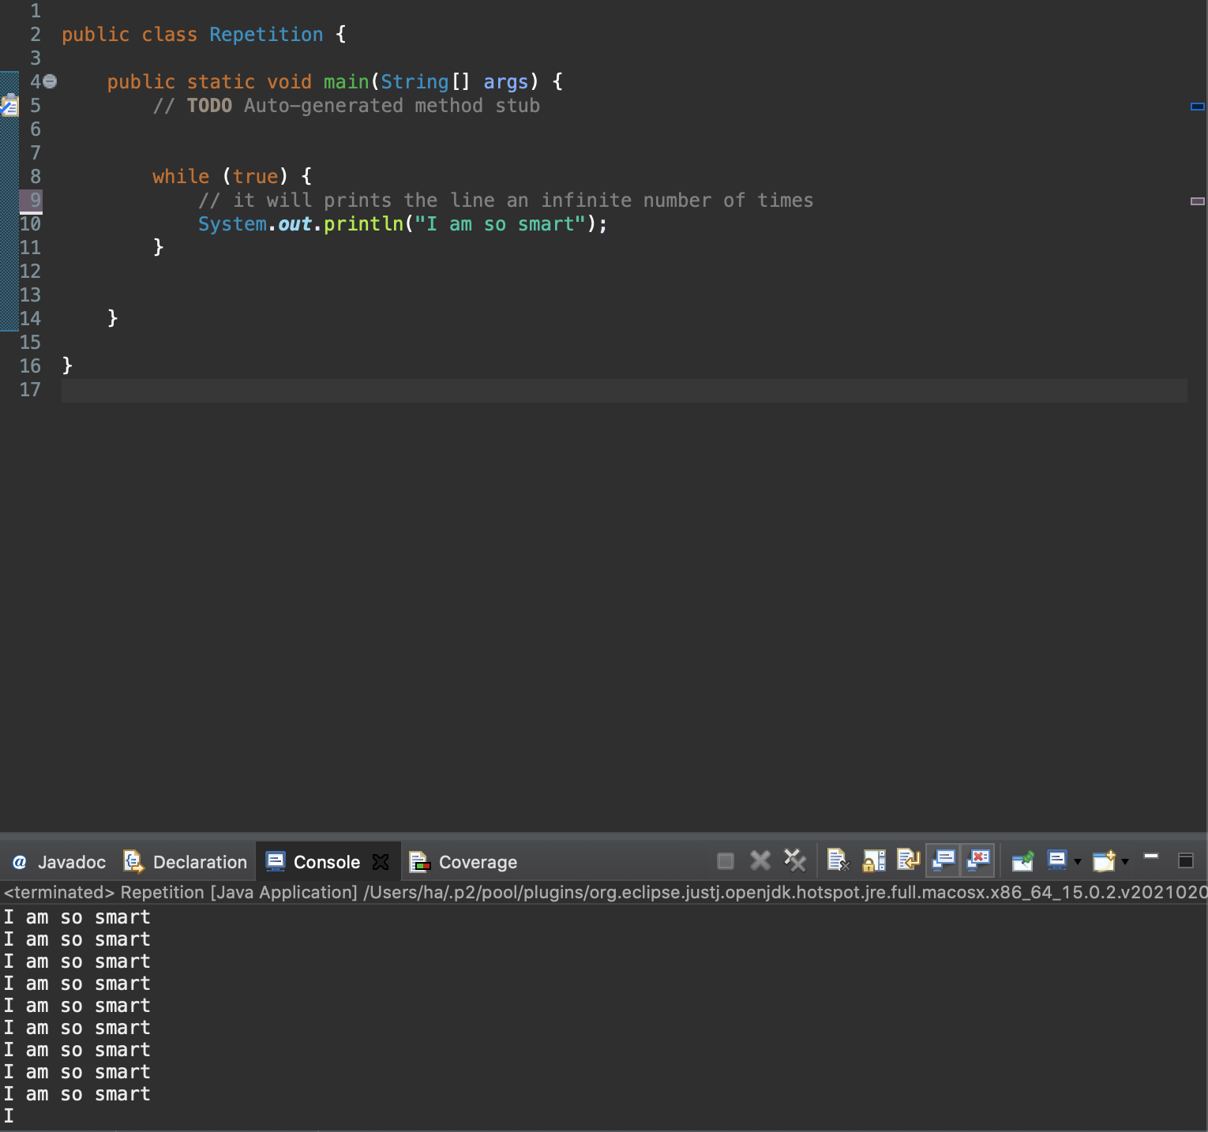

1. Write a program that prints the same line from question 3 exactly 10 times.

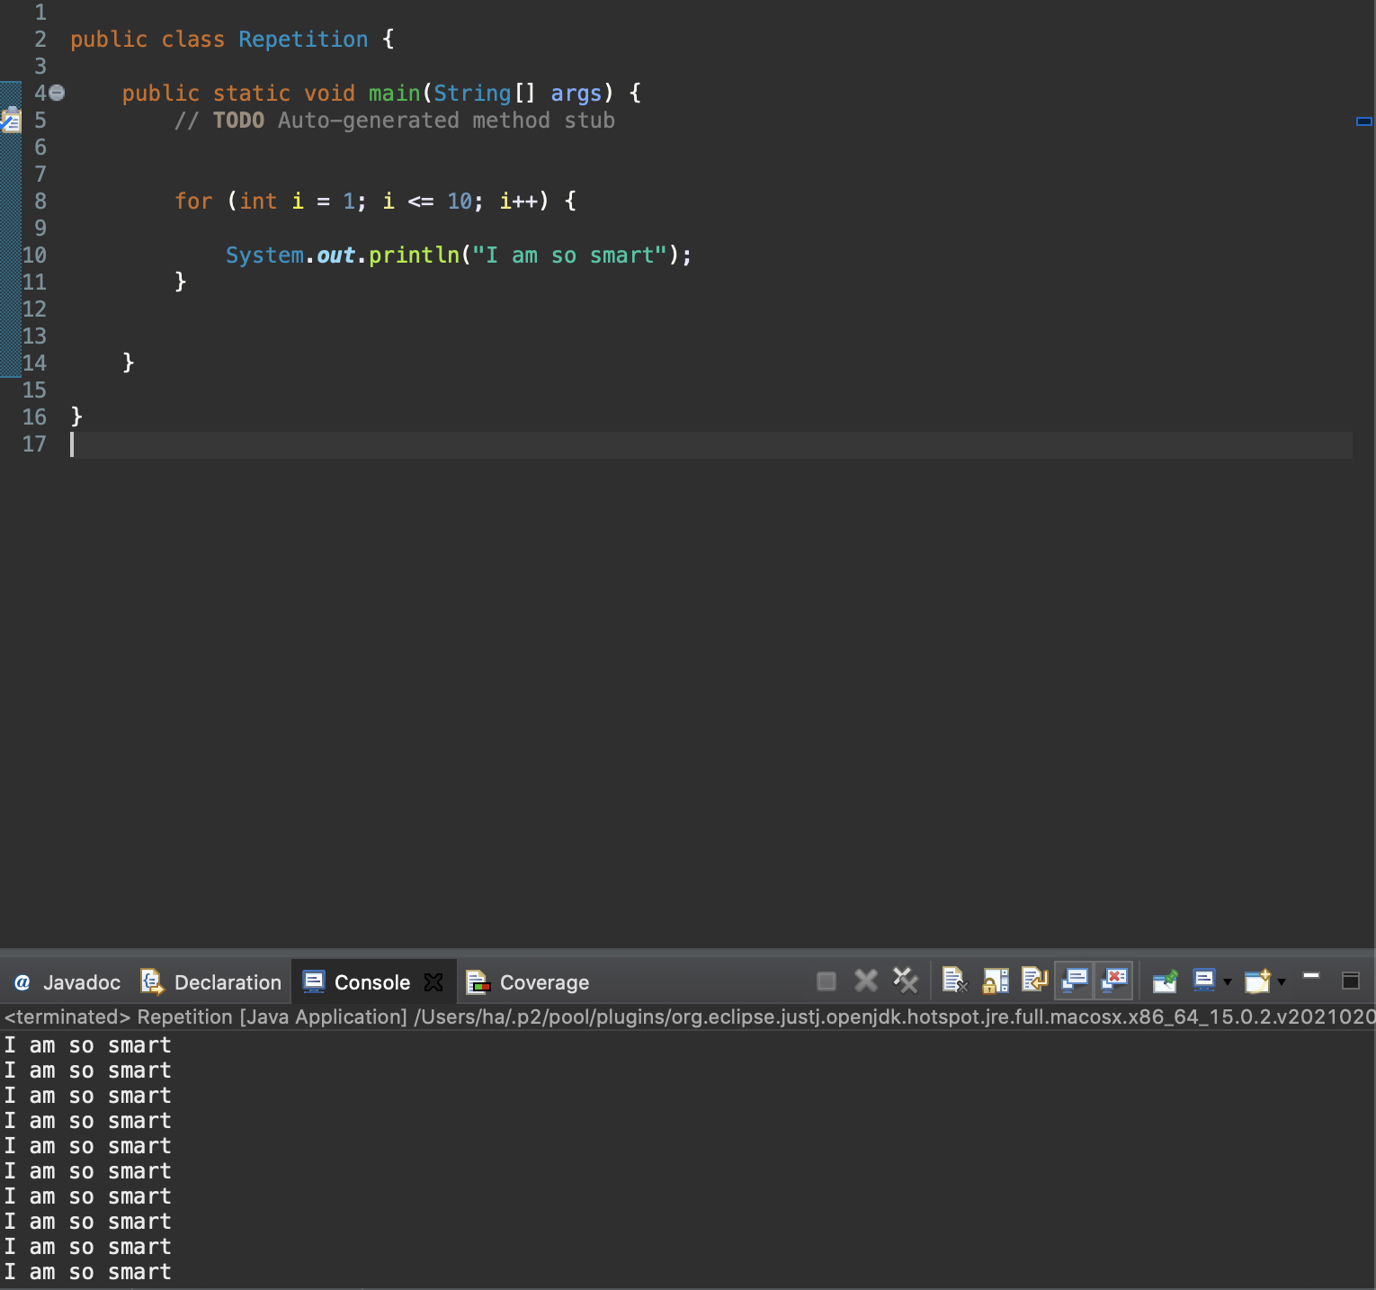

1. Write a program that…

a) prints the same line from question 2)

b) keeps track of how many times the line is printed

c) repeats until the user does not wish to continue

d) prints the number of times the loop is printed

|  |
| --- |
| Sample Output |
| I am so smart  Do you wish to continue? Yes  I am so smart  Do you wish to continue? No  Number of times the loop was executed: 2 |

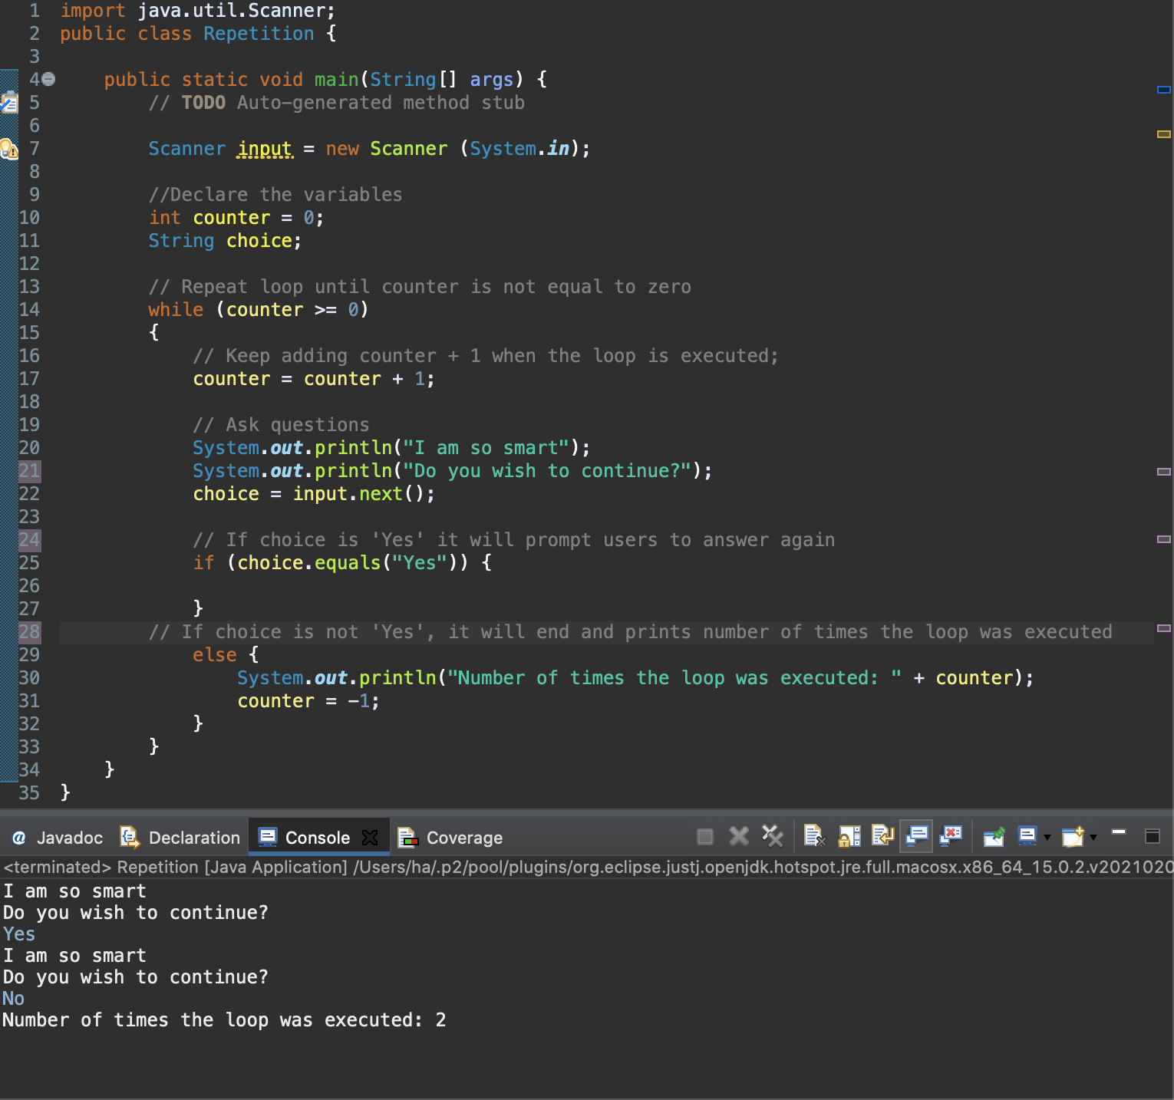

1. Write a fragment that forces a user to supply either y or n in response to the question “Continue? Respond with y or n”.

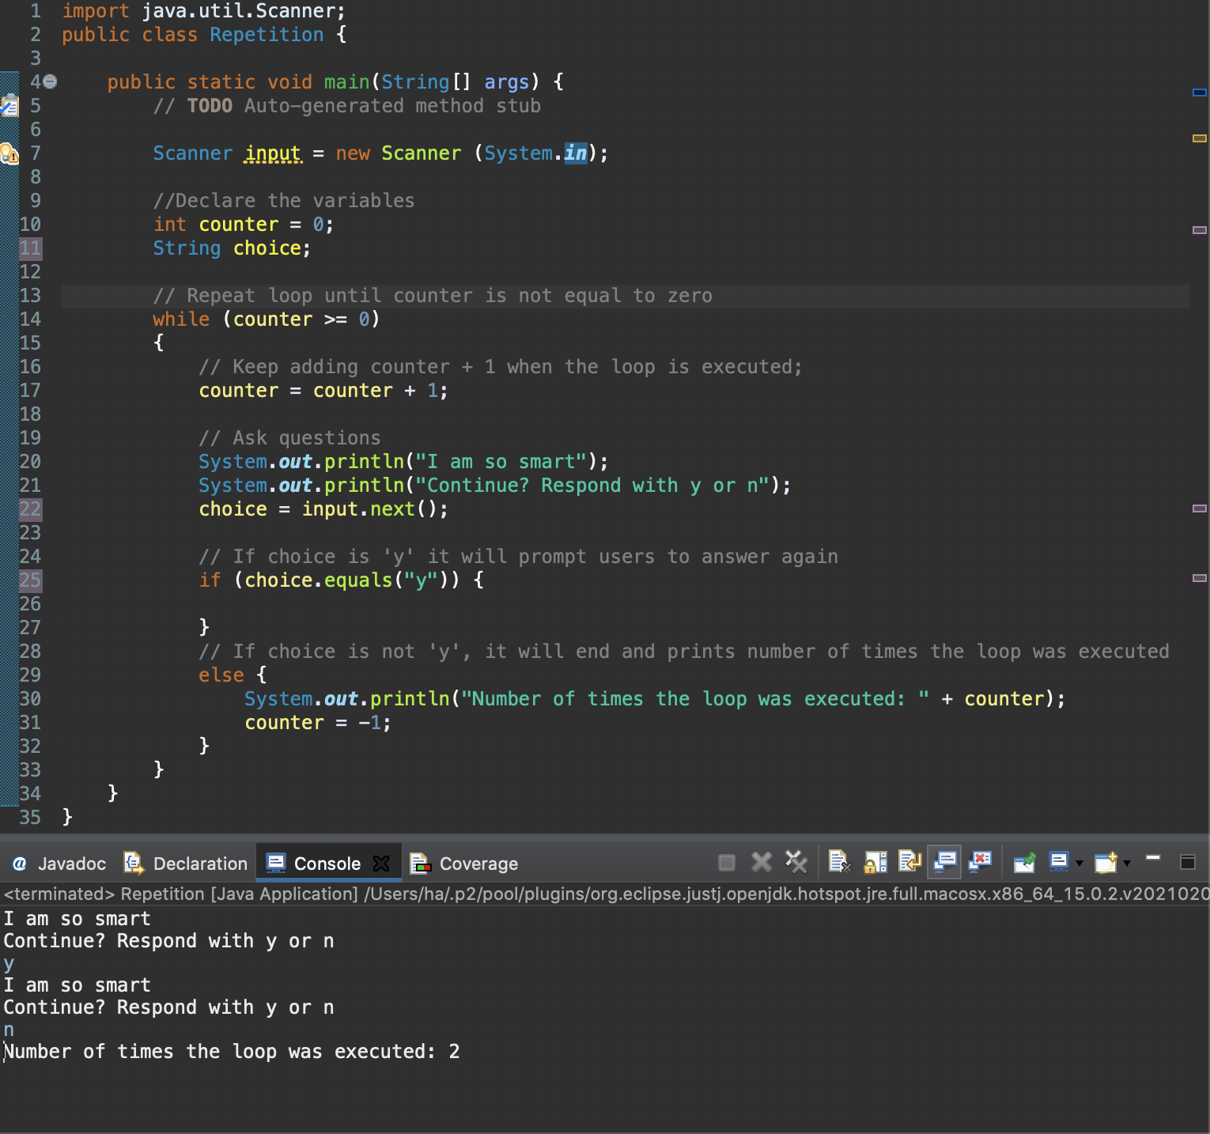

1. Write a program fragment that asks the user to supply a string , repeatedly rejecting responses until the user gives the string “excellent”.

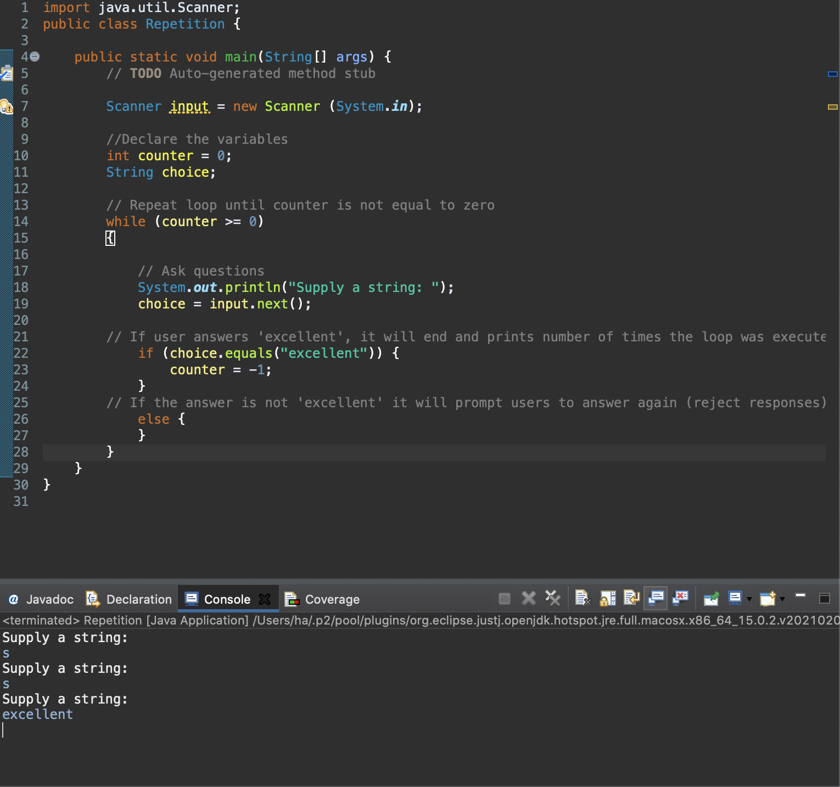

1. Write a program that first forces the user to supply a positive integer and then prints the number and the sum of its digits.

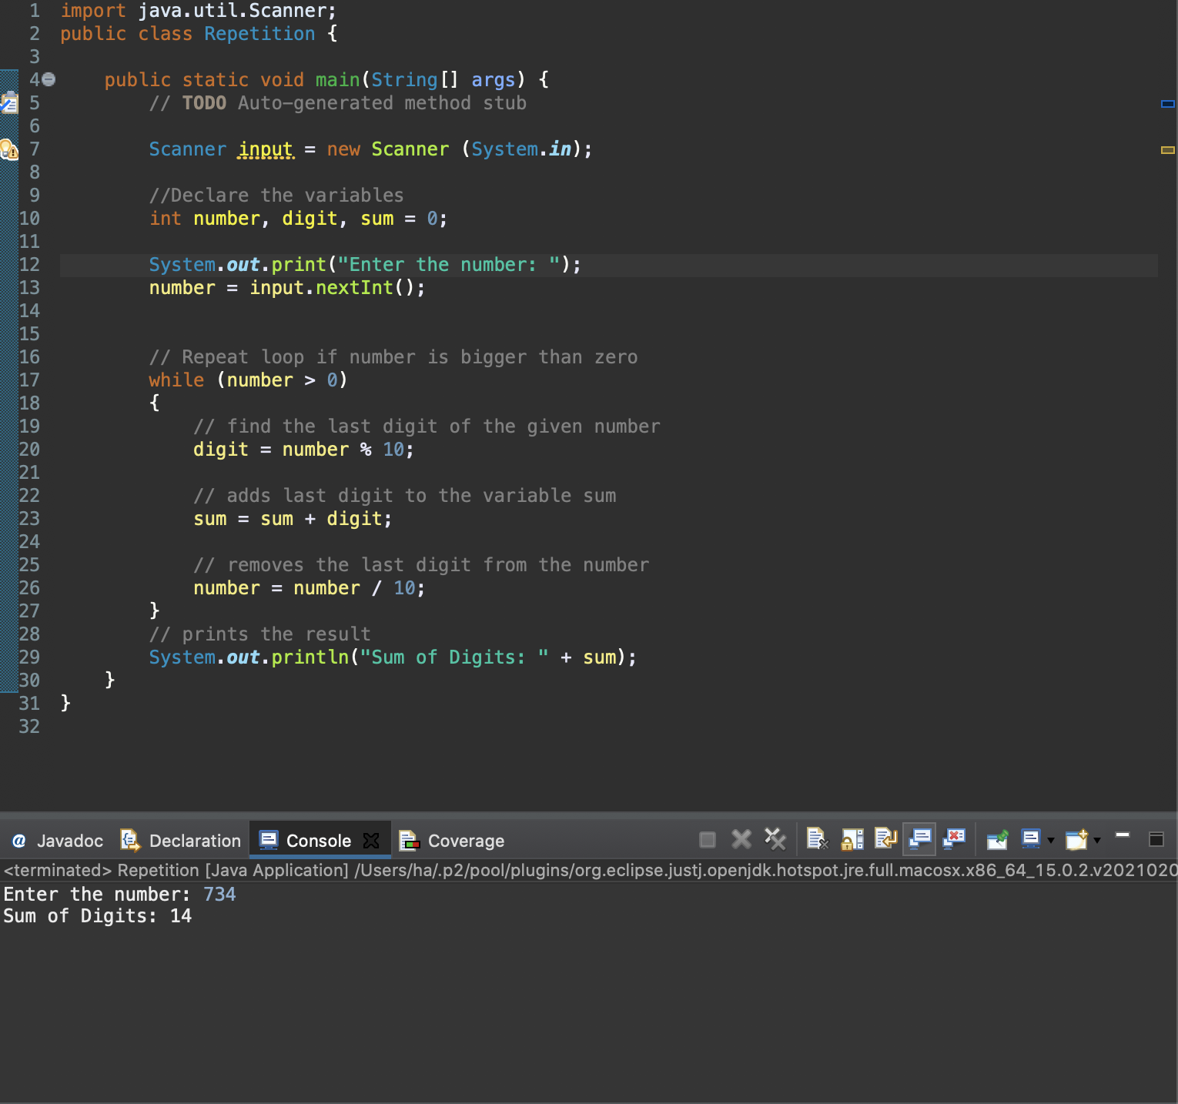

1. Using a counted loop, write a program that prints

a)1 up to 10

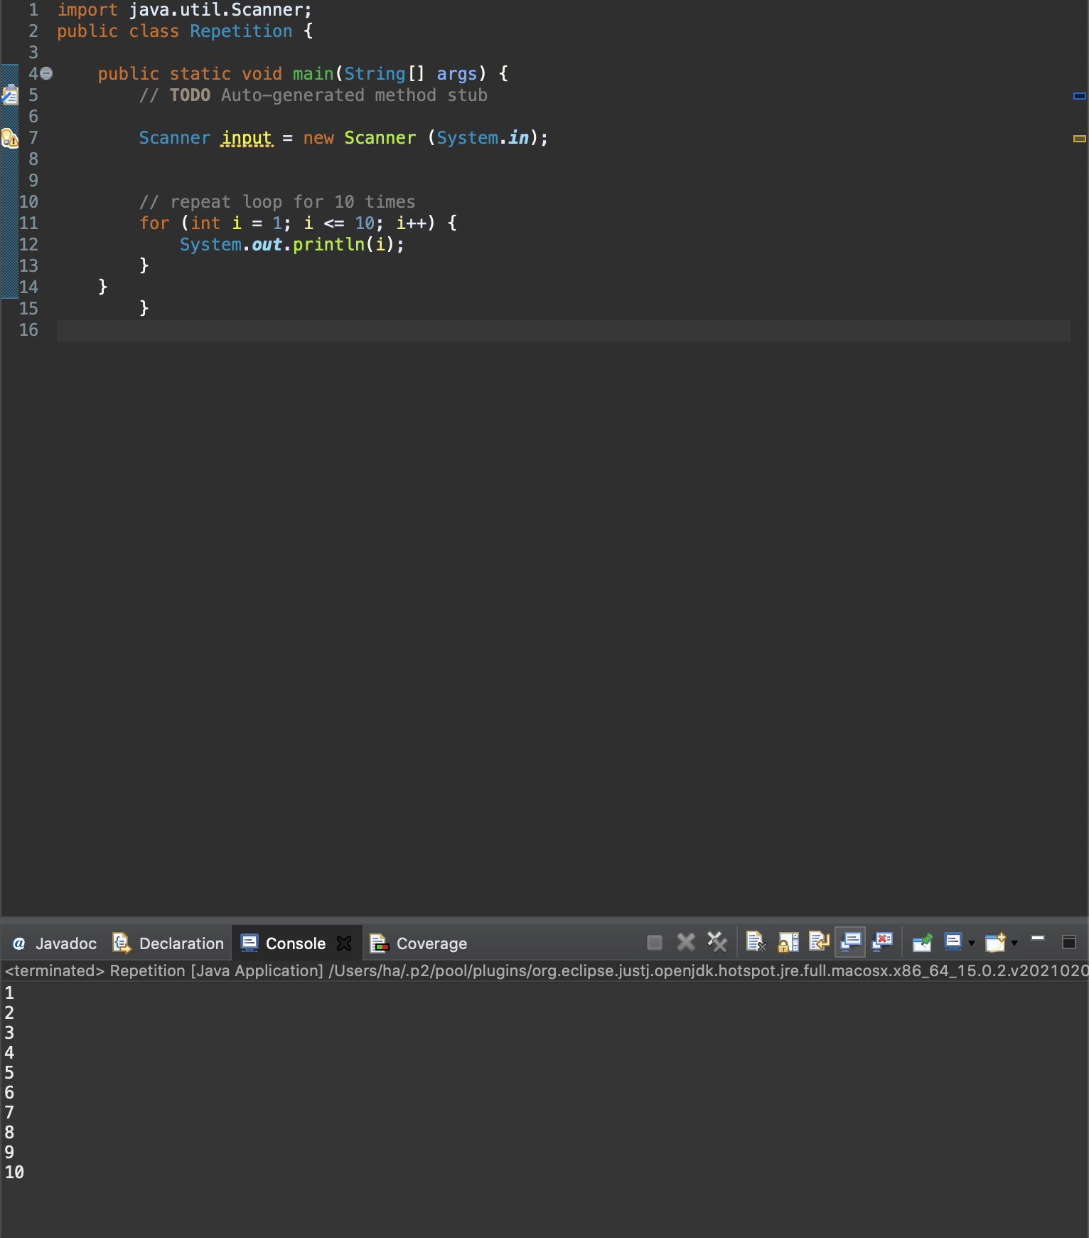

b) a running total of the integers.

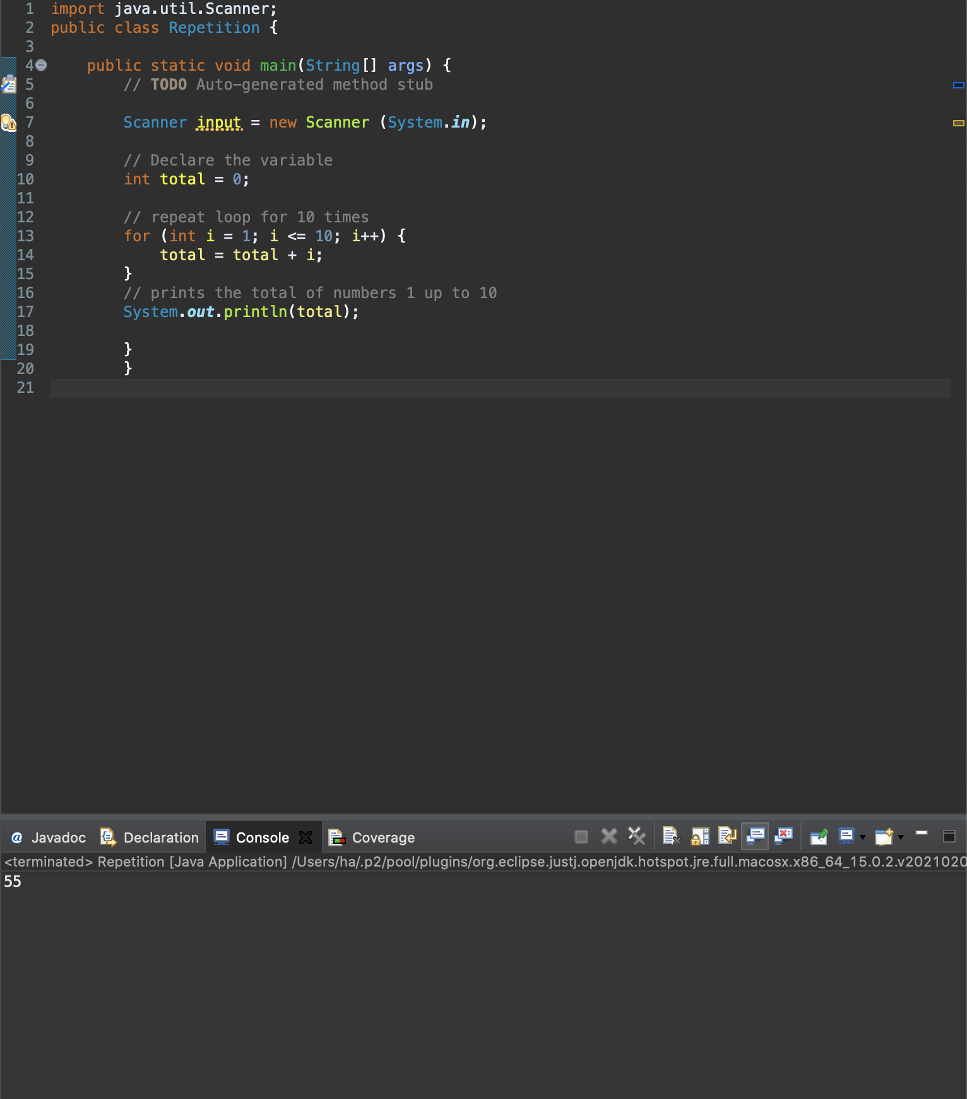

1. Using a counted loop, write a program that prints

a)1 up to 5

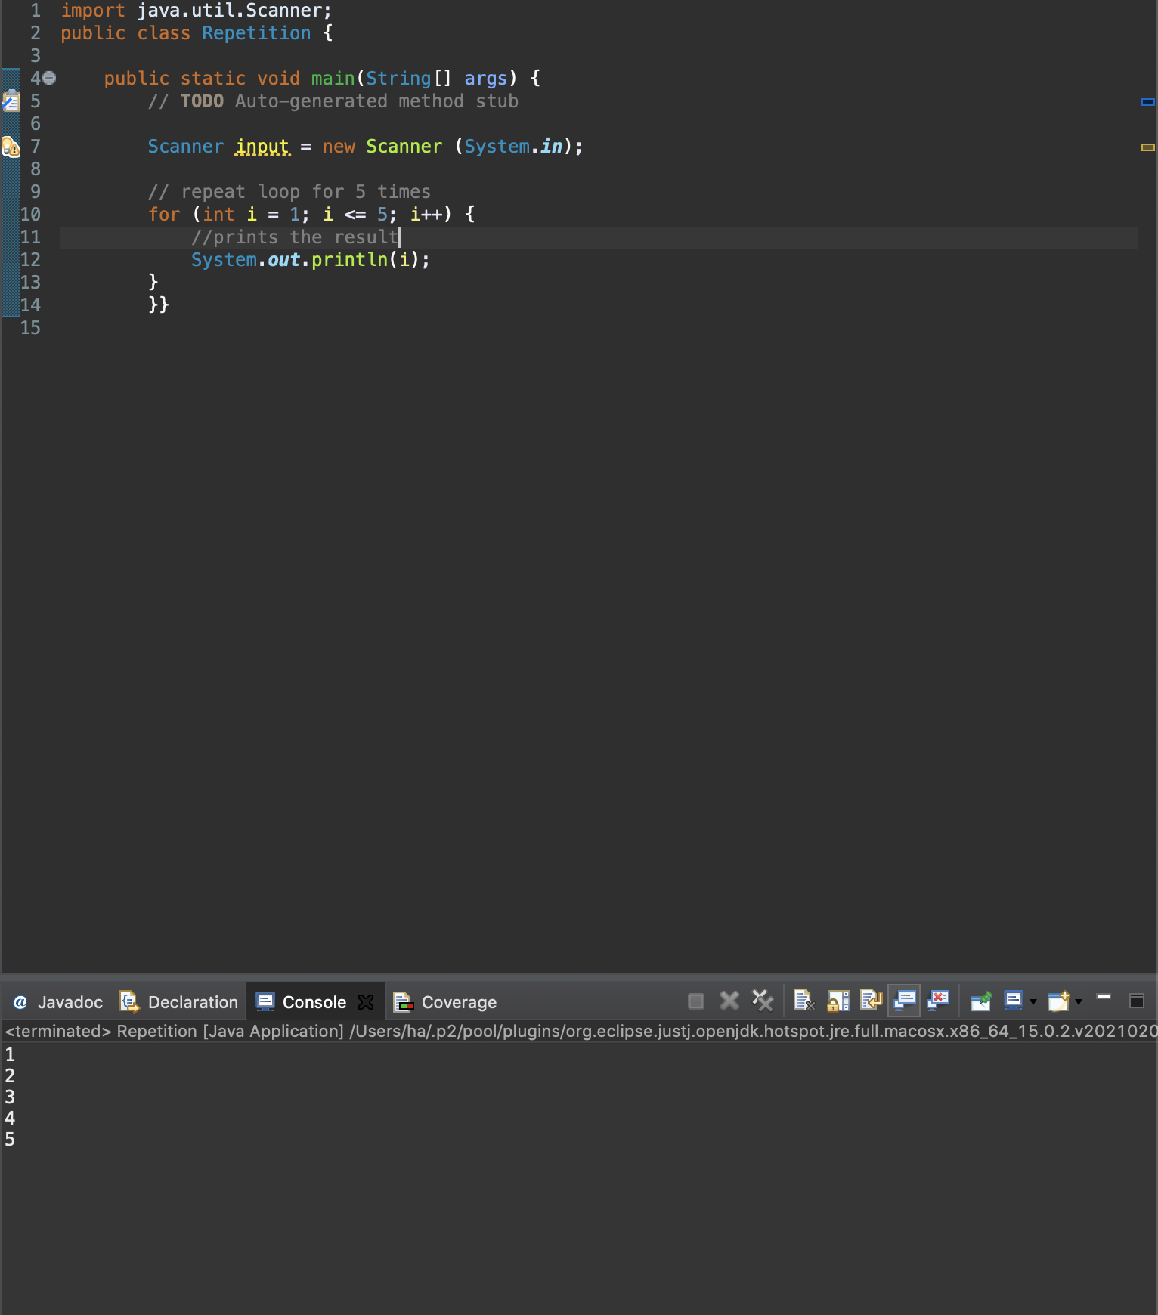

b) the square of each number.

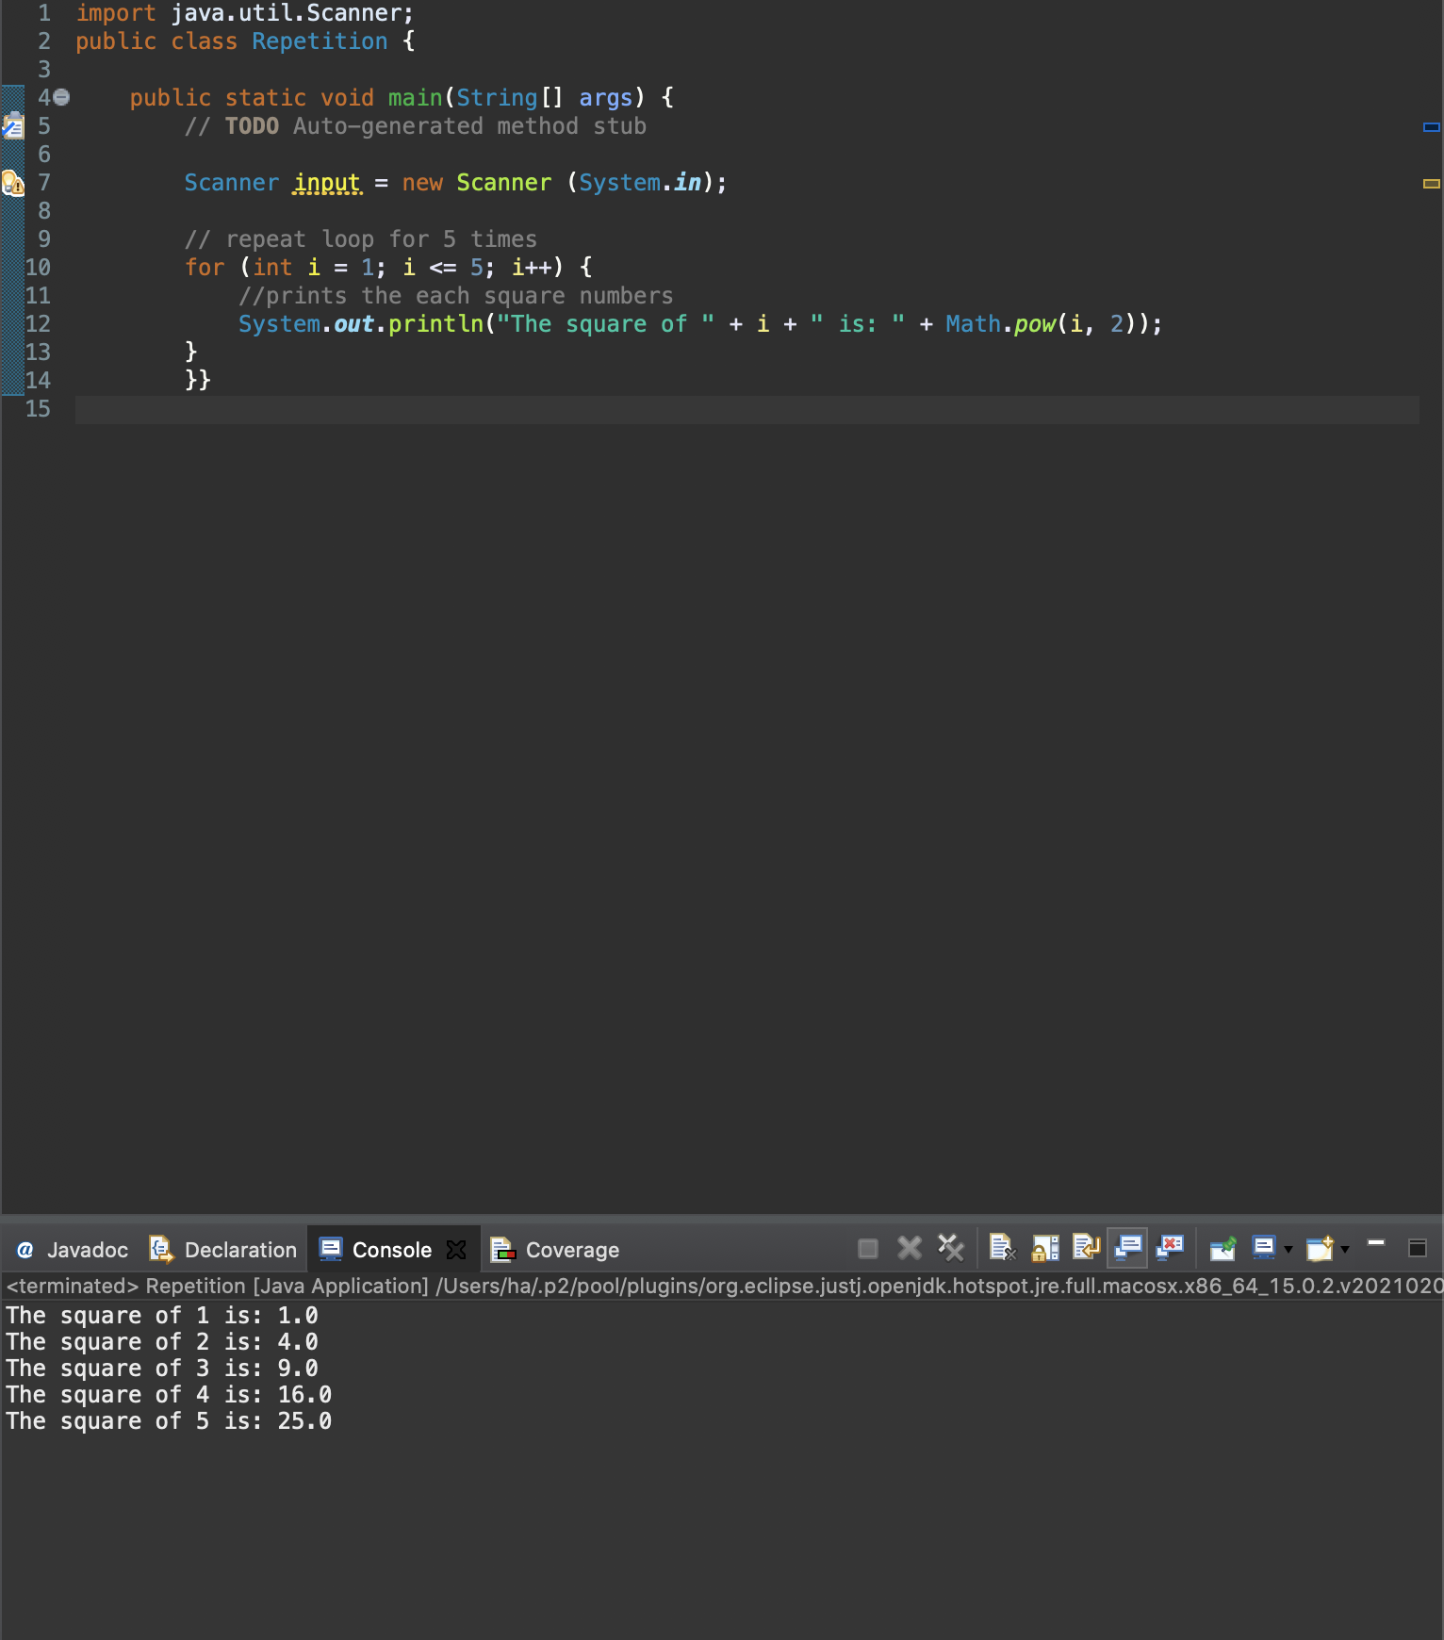

c) a running total of the numbers.

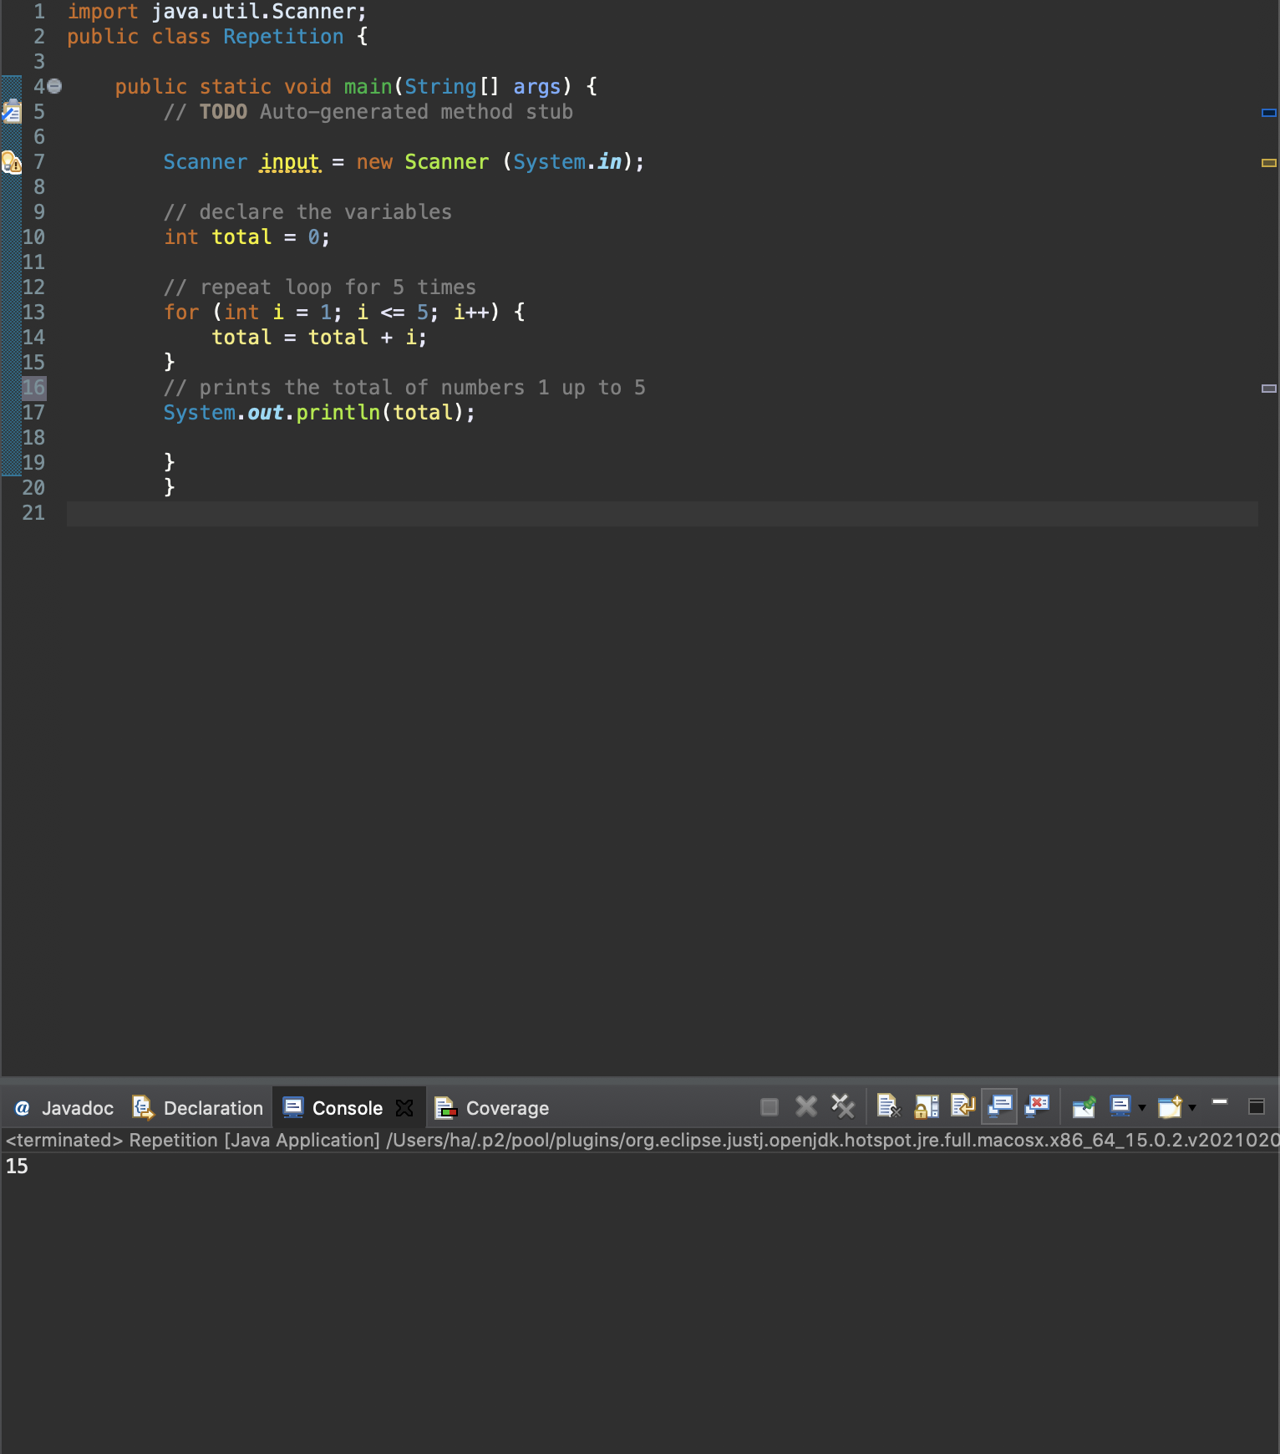

1. Write statements that will print a table of values of the function f(x) = 2x + 5 for the indicated values of x.

For example if x = 6,5,4,….0

|  |
| --- |
| SAMPLE OUTPUT |
| x= 6, 2x + 5 = 17  x= 5, 2x + 5 = 15  …….. |

1. x = 0, 3, 6, …., 30

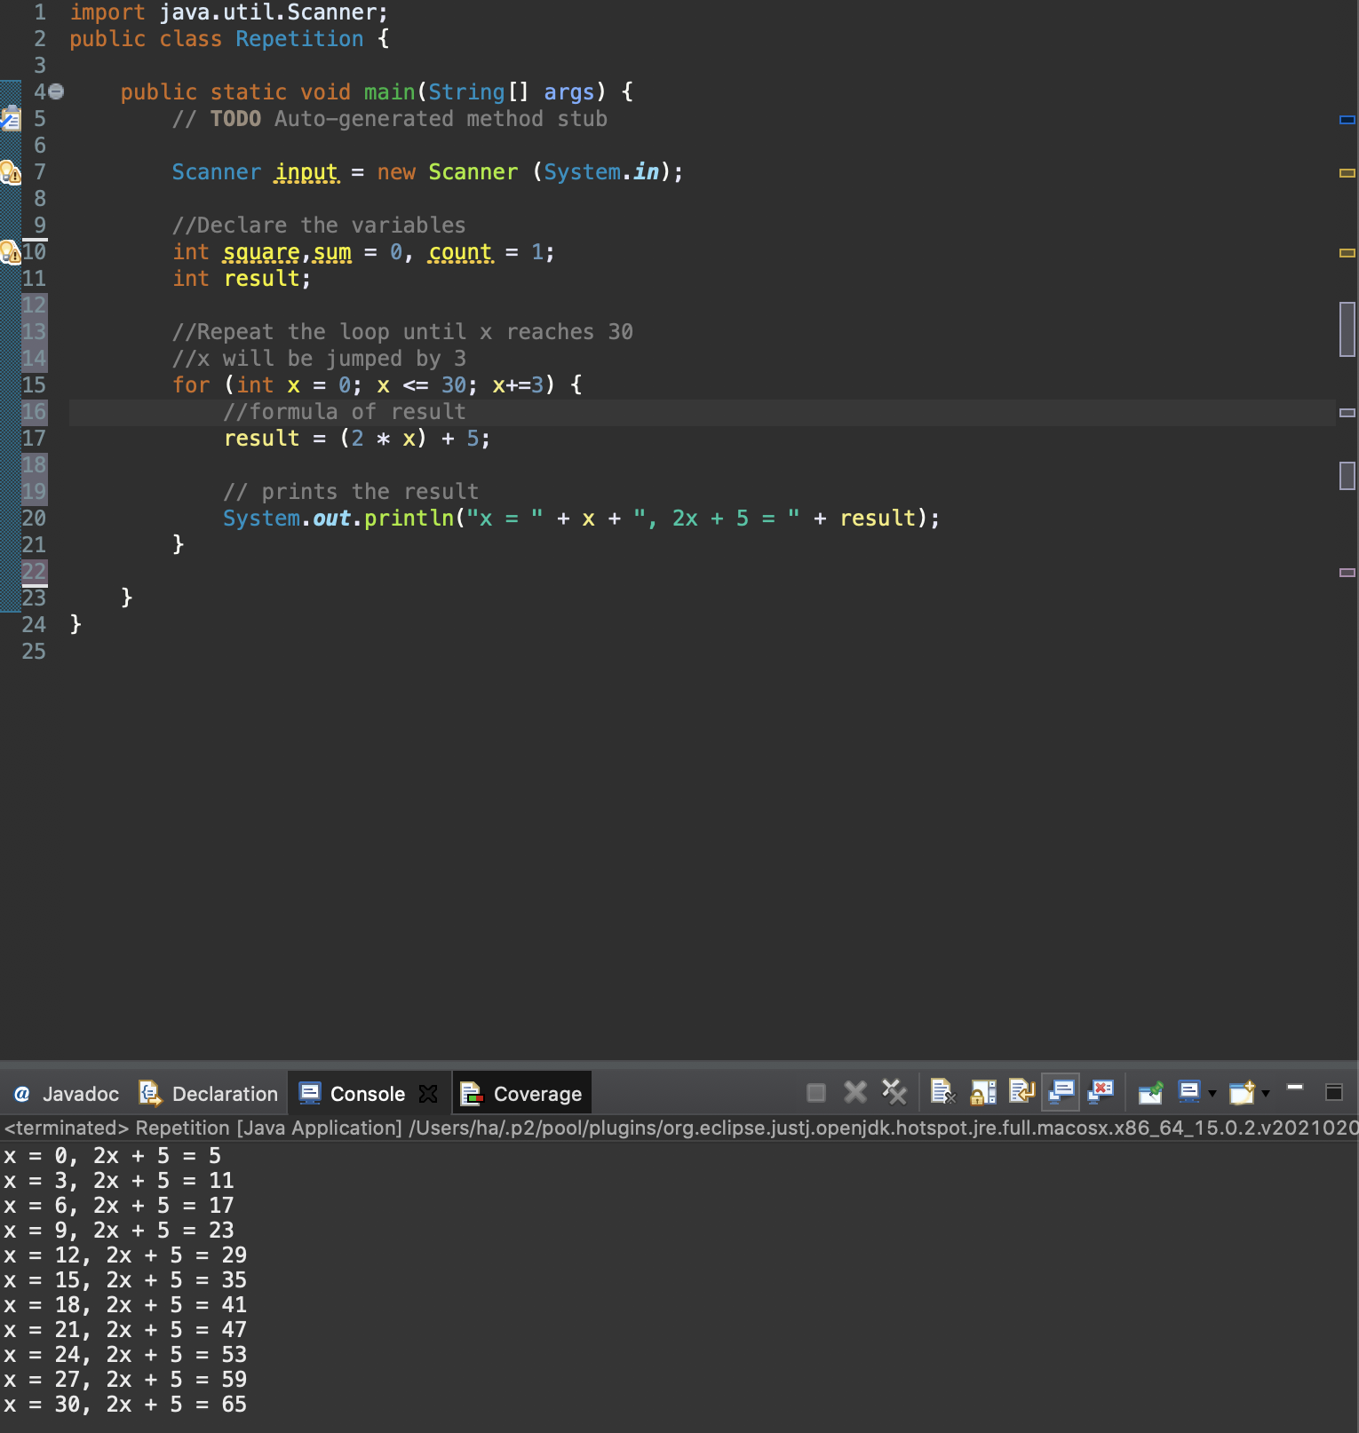

1. x = -15, -10, -5, ….. 15

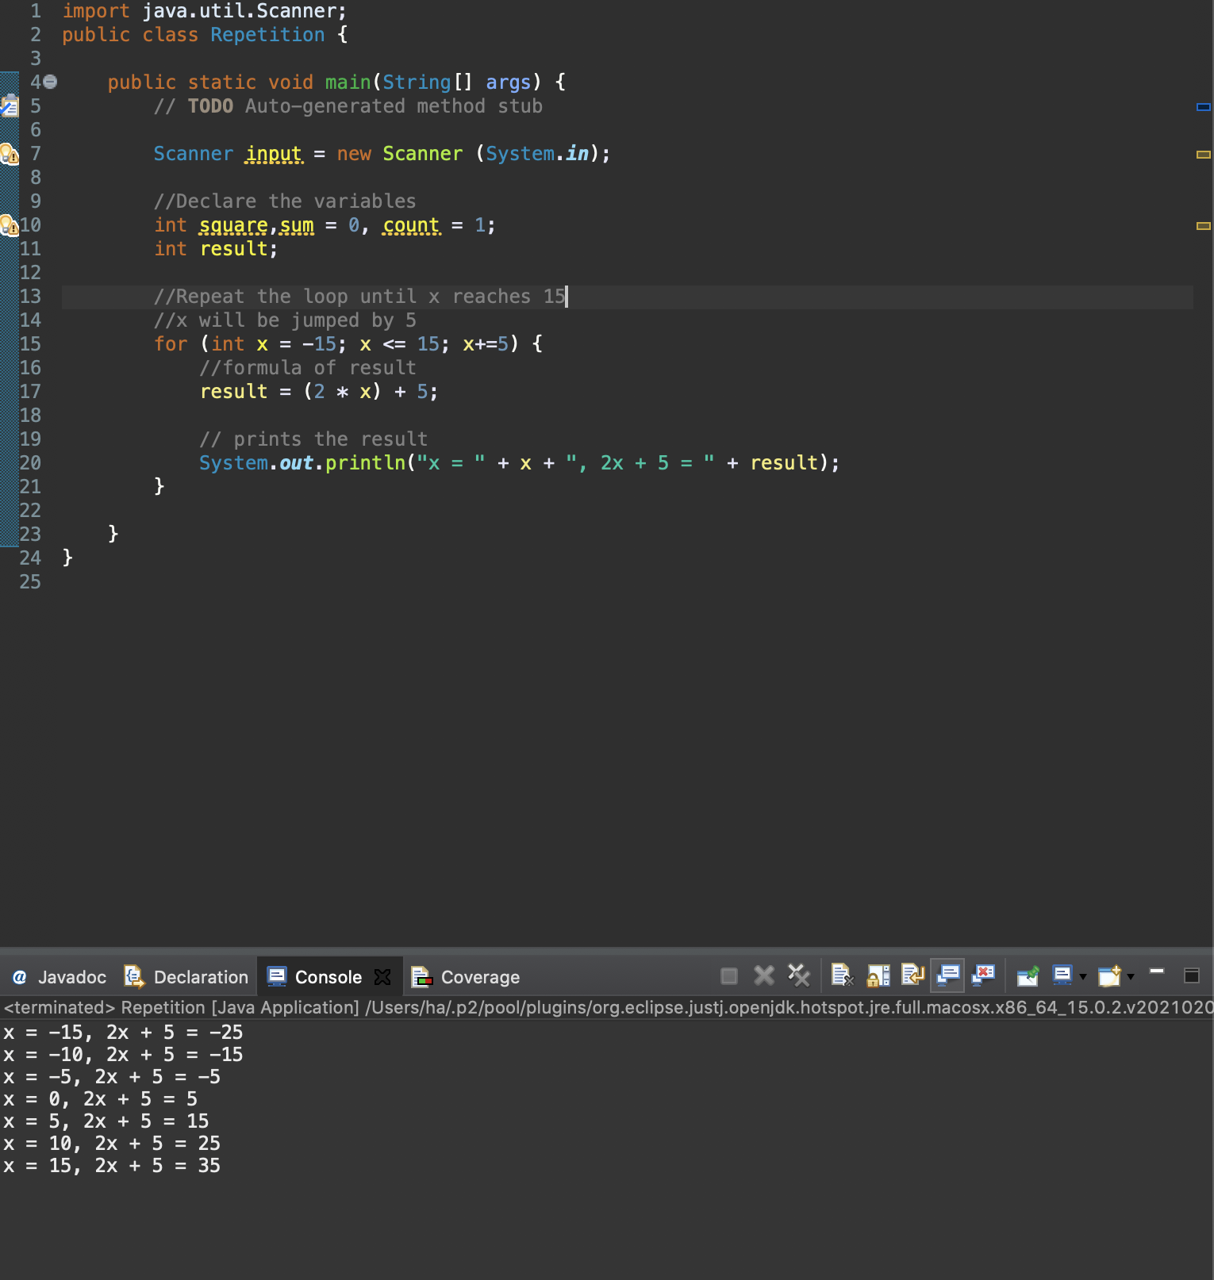

1. x = 1, 2, 4, 8, …., 1024

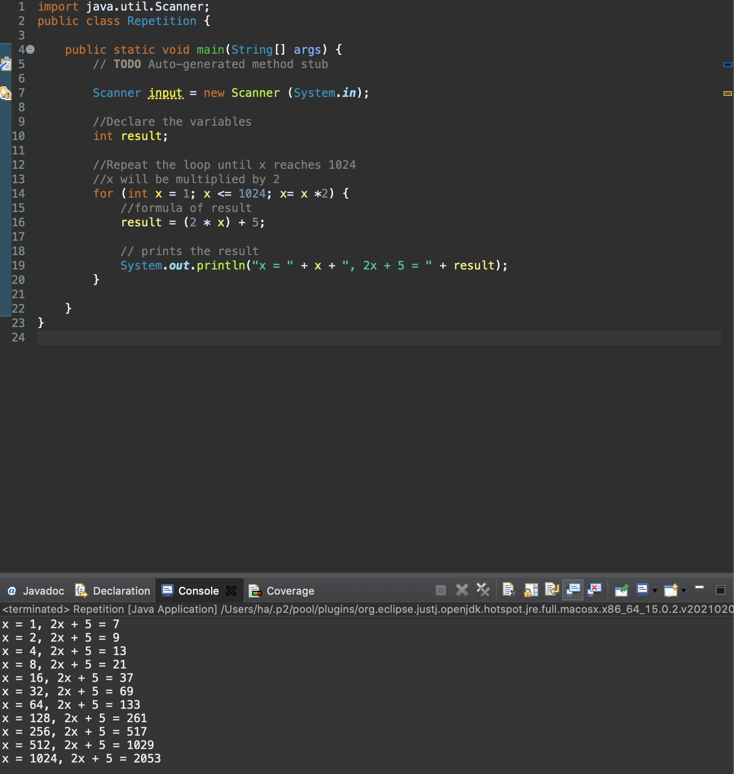

1. Suppose that a large piece of paper with an area of 1.0 m2 and a thickness of 0.090 mm is cut in half and the two pieces are stacked, one on top of the other. Suppose further that the process of cutting in half and stacking is repeated over and over again.

Write a program to find both the thickness of the pile and the area of each piece after the procedure has been carried out forty times.

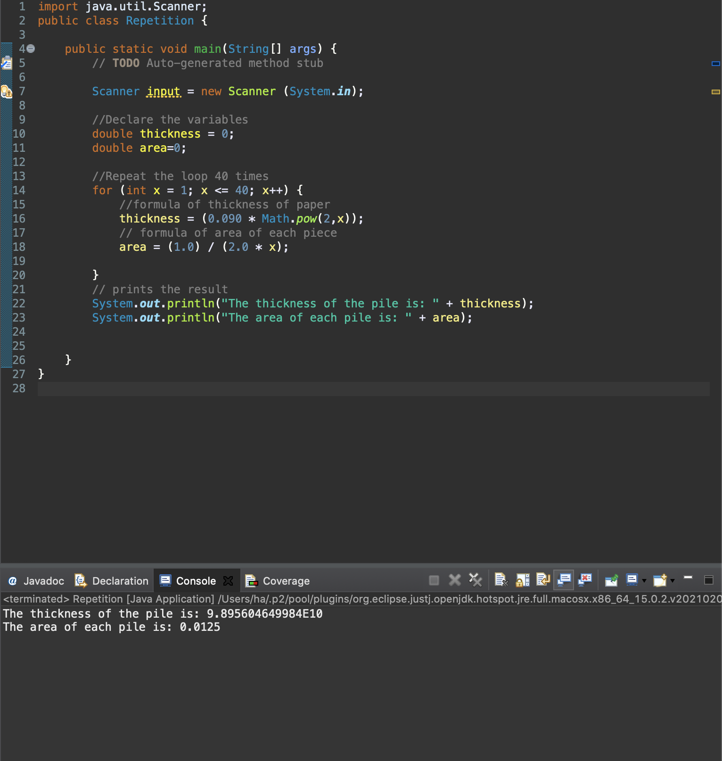

1. Write a program that reads a positive integer n and then pints an “n-times table” containing values up to n x n.

For example, if the program reads the value 5, it should print

|  |
| --- |
| SAMPLE OUTPUT |
| 5 x 1 = 5  5 x 2 = 10  5 x 3 = 15  5 x 4 = 20  5 x 5 = 25 |

Assume that the input is valid

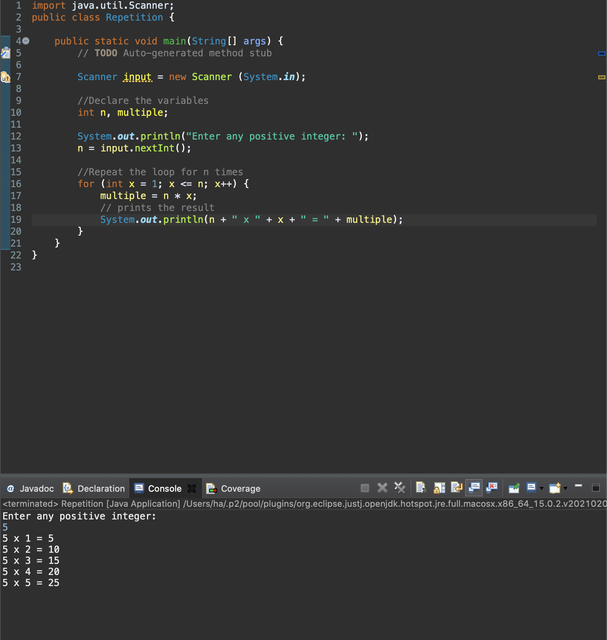

1. Write a program that….

a) Asks a user to enter 4 marks (each out of a 100) for a student

b) Calculate and print the average of the student’s marks.

c) repeat steps a and b for another student until the user is finished

